26.17:
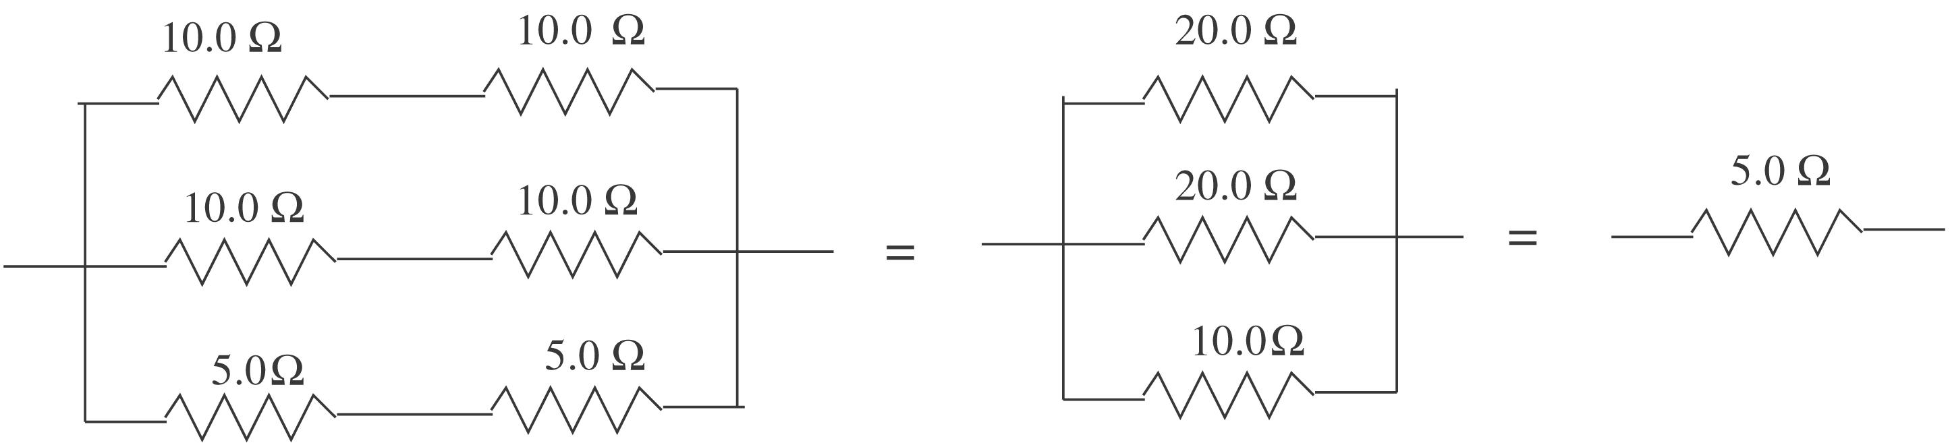

I = 1.00 A
For the 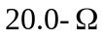 resistor thermal energy is generated at the rate 